# **AWS**

# 

# **Deploy Low Latency Apps to AWS Local Zones**

Step1 : login to aws management console and navigate to ec2 dashboard.

Step 2: in ec2 dashboard ,click on “zones”.

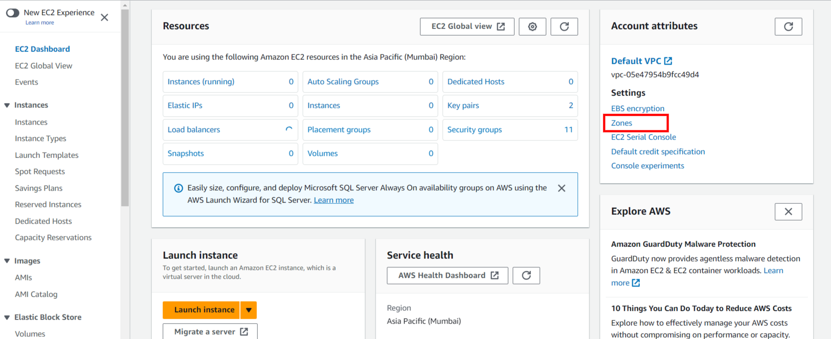

Step 3:Now ,choose the local zone you want to enable ,then click on “edit” and then “enable” the local zone and click on “save changes”.

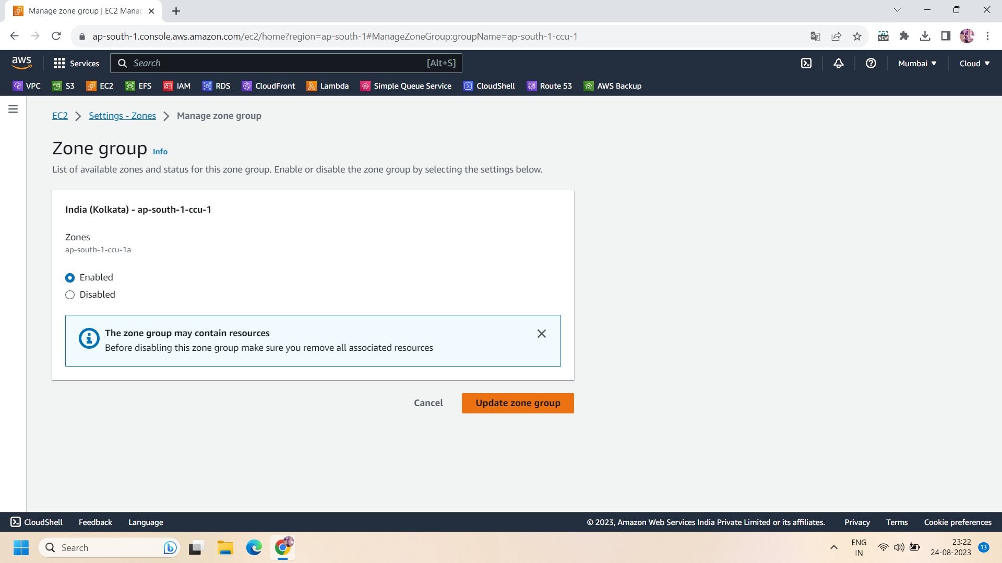

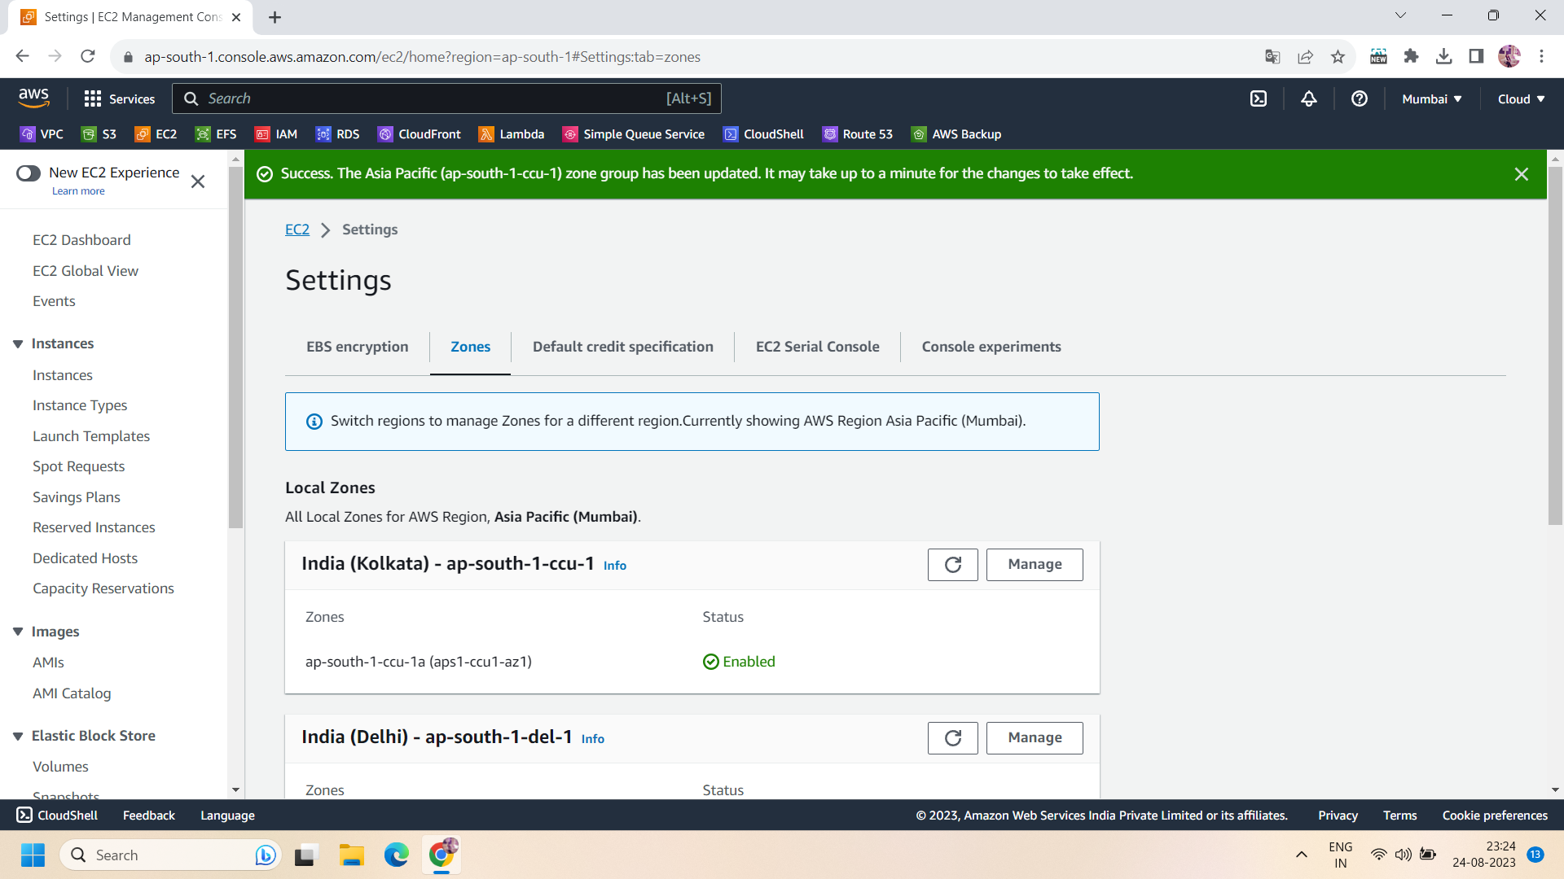

Step 4: After enabling the local zone,go to the VPC dashboard and create a subnet with the local zone in a VPC.

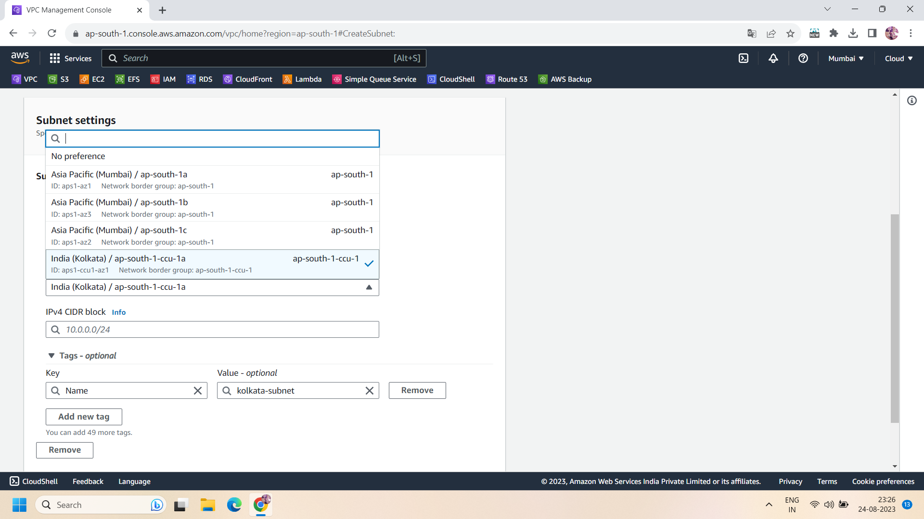

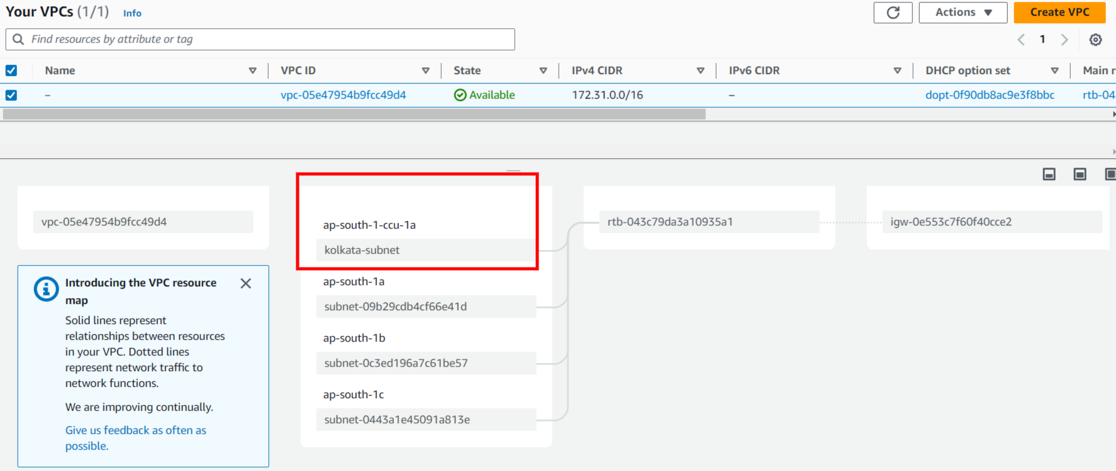

Step 5: now ,launch a linux ec2 instance with the local zone subnet and allow HTTP .

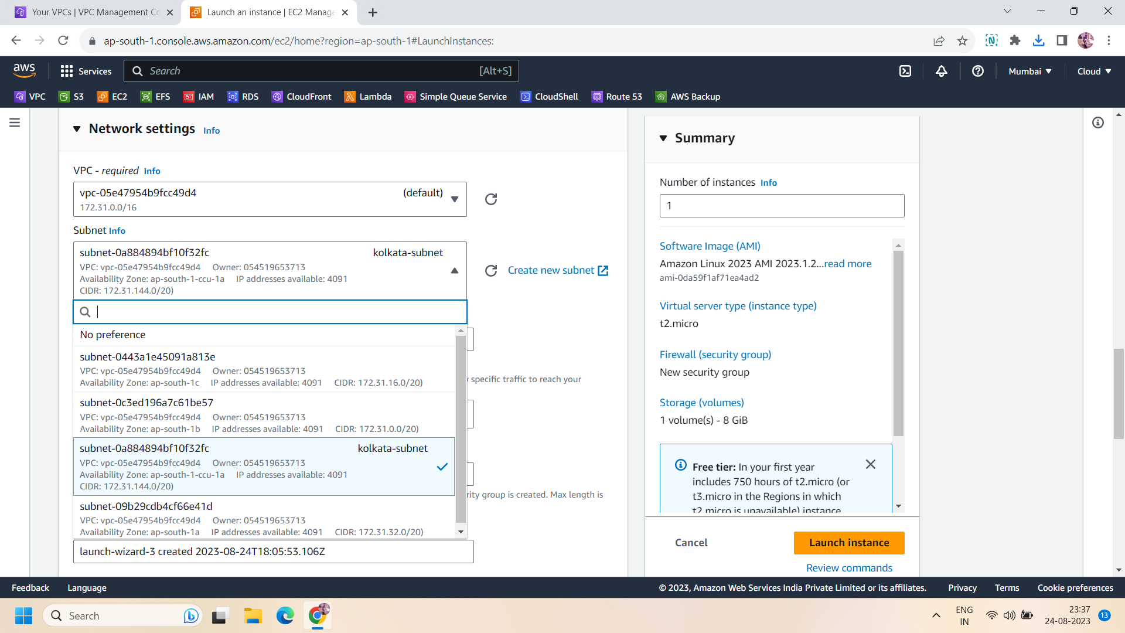

Step 6: now take the SSH of the ec2 instance and download nginx by the following command :

Sudo yum install nginx -y

Step 7: After installing the nginx,start the nginx. To start,sun the following command:

systemctl start nginx

Step 8: now go to your ec2 instance and copy it public IP and paste into browser.it will show you your nginx default page.

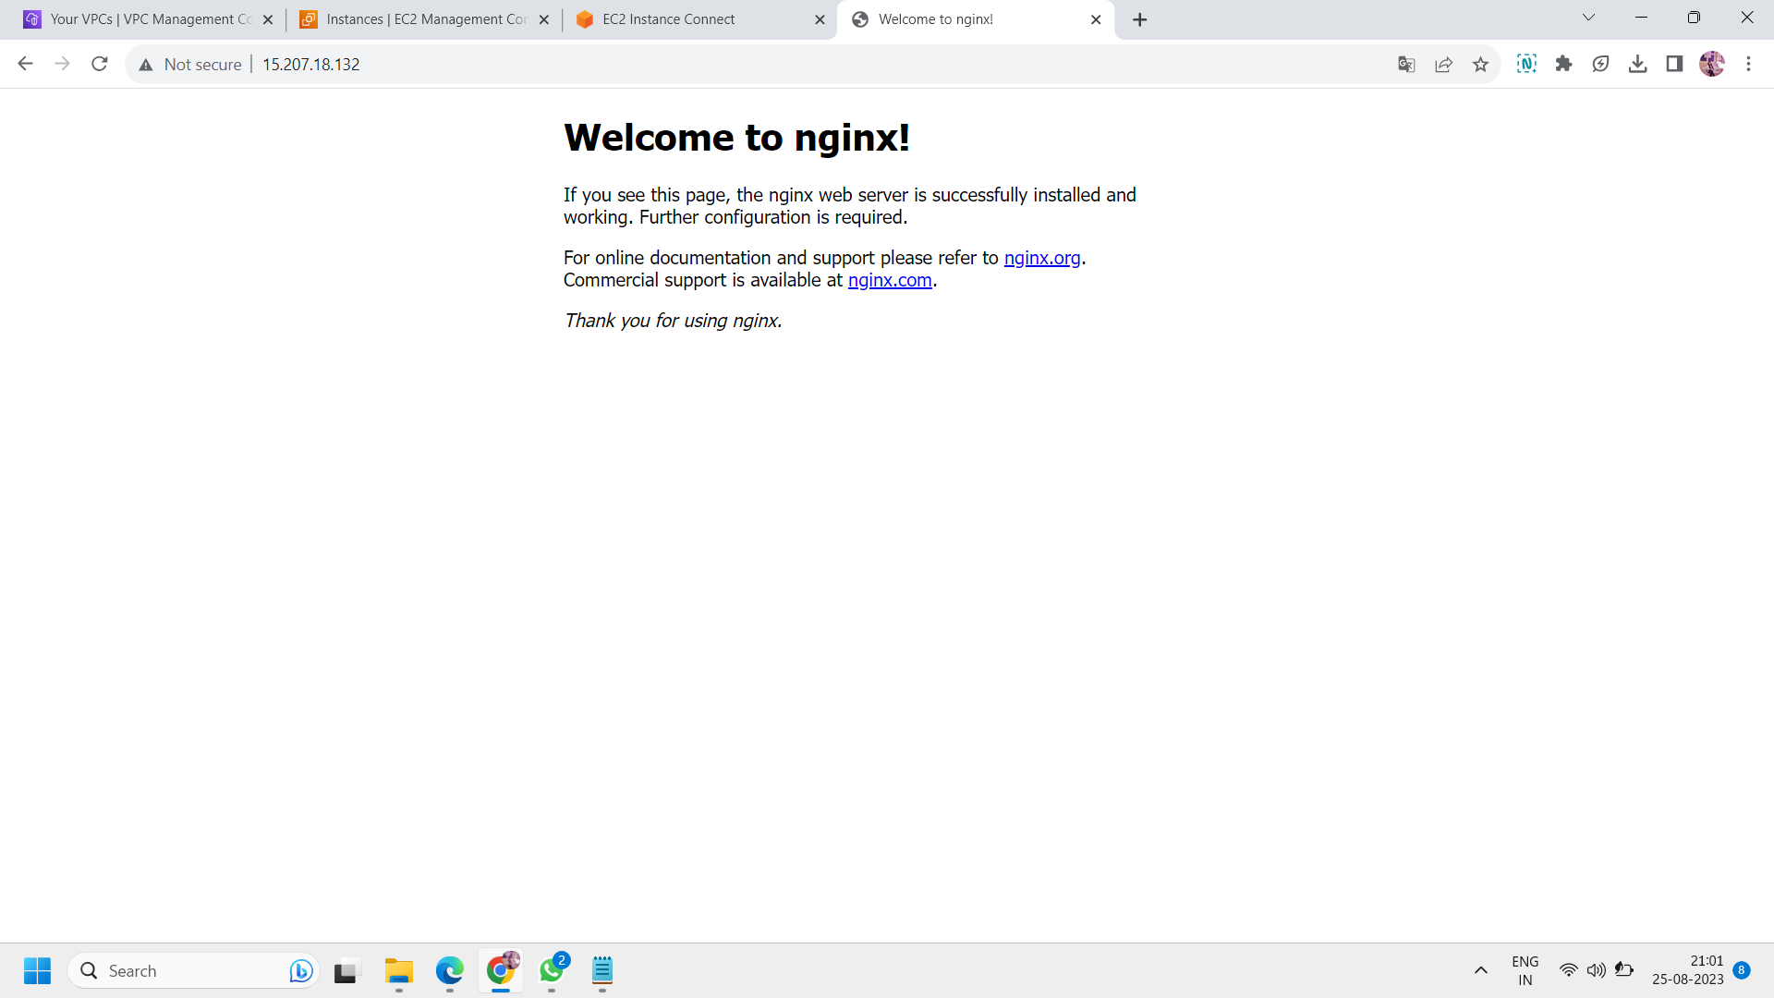

Step 9: after performing the above steps,don't forget to disable the local zone .but to disable the local zone ,you have to raise request to aws for disable the local zone.you can only enable it for disable you have to go to aws support but after disassociate all the resources attached to local zone.

ALL done!!